UNITED STATES
SECURITIES AND EXCHANGE COMMISSION
Washington, D.C. 20549

SCHEDULE 14A

Proxy Statement Pursuant to Section 14(a) of the
Securities Exchange Act of 1934
(Amendment No. )

☒ |  | Filed by the Registrant |  | ☐ |  | Filed by a party other than the Registrant

CHECK THE APPROPRIATE BOX:
☐ |  | Preliminary Proxy Statement
☐ |  | Confidential, for Use of the Commission Only (as permitted by Rule 14a-6(e)(2))
☐ |  | Definitive Proxy Statement
☒ |  | Definitive Additional Materials
☐ |  | Soliciting Material under §240.14a-12



Medline Inc.

(Name of Registrant as Specified In Its Charter)
(Name of Person(s) Filing Proxy Statement, if other than the Registrant)

PAYMENT OF FILING FEE (CHECK ALL BOXES THAT APPLY):
☒ |  | No fee required
☐ |  | Fee paid previously with preliminary materials
☐ |  | Fee computed on table in exhibit required by Item 25(b) per Exchange Act Rules 14a-6(i)(1) and 0-11

 | 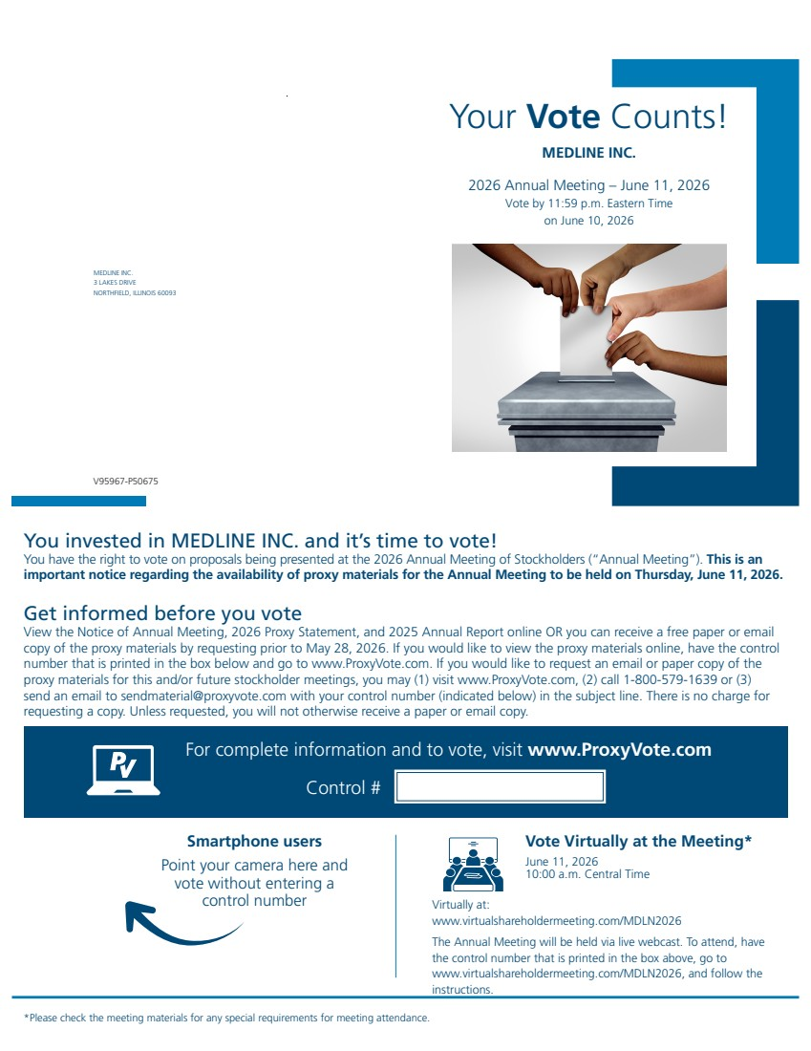 | Your Vote Counts! MEDLINE INC. 3 LAKES DRIVE NORTHFIELD, ILLINOIS 60093 MEDLINE INC. 2026 Annual Meeting – June 11, 2026 Vote by 11:59 p.m. Eastern Time on June 10, 2026 You invested in MEDLINE INC. and it’s time to vote! You have the right to vote on proposals being presented at the 2026 Annual Meeting of Stockholders (“Annual Meeting”). This is an important notice regarding the availability of proxy materials for the Annual Meeting to be held on Thursday, June 11, 2026. Vote Virtually at the Meeting* June 11, 2026 10:00 a.m. Central Time Virtually at: www.virtualshareholdermeeting.com/MDLN2026 The Annual Meeting will be held via live webcast. To attend, have the control number that is printed in the box above, go to www.virtualshareholdermeeting.com/MDLN2026, and follow the instructions. *Please check the meeting materials for any special requirements for meeting attendance. Smartphone users Point your camera here and vote without entering a control number For complete information and to vote, visit www.ProxyVote.com Control # V95967-P50675 Get informed before you vote View the Notice of Annual Meeting, 2026 Proxy Statement, and 2025 Annual Report online OR you can receive a free paper or email copy of the proxy materials by requesting prior to May 28, 2026. If you would like to view the proxy materials online, have the control number that is printed in the box below and go to www.ProxyVote.com. If you would like to request an email or paper copy of the proxy materials for this and/or future stockholder meetings, you may (1) visit www.ProxyVote.com, (2) call 1-800-579-1639 or (3) send an email to sendmaterial@proxyvote.com with your control number (indicated below) in the subject line. There is no charge for requesting a copy. Unless requested, you will not otherwise receive a paper or email copy.
 | 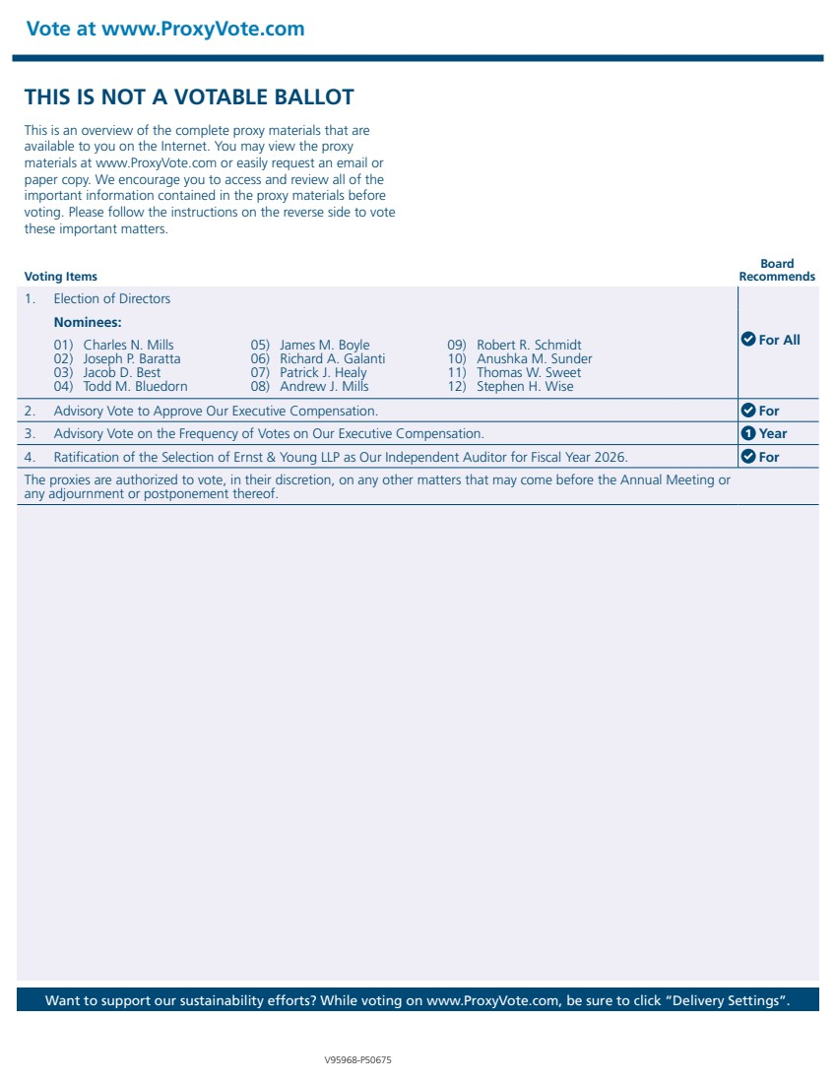 | THIS IS NOT A VOTABLE BALLOT This is an overview of the complete proxy materials that are available to you on the Internet. You may view the proxy materials at www.ProxyVote.com or easily request an email or paper copy. We encourage you to access and review all of the important information contained in the proxy materials before voting. Please follow the instructions on the reverse side to vote these important matters. Vote at www.ProxyVote.com Want to support our sustainability efforts? While voting on www.ProxyVote.com, be sure to click “Delivery Settings”. Voting Items Board Recommends V95968-P50675 1. Election of Directors For All Nominees: 01) Charles N. Mills 02) Joseph P. Baratta 03) Jacob D. Best 04) Todd M. Bluedorn 05) James M. Boyle 06) Richard A. Galanti 07) Patrick J. Healy 08) Andrew J. Mills 09) Robert R. Schmidt 10) Anushka M. Sunder 11) Thomas W. Sweet 12) Stephen H. Wise 2. Advisory Vote to Approve Our Executive Compensation. For 3. Advisory Vote on the Frequency of Votes on Our Executive Compensation. 1 Year 4. Ratification of the Selection of Ernst & Young LLP as Our Independent Auditor for Fiscal Year 2026. For The proxies are authorized to vote, in their discretion, on any other matters that may come before the Annual Meeting or any adjournment or postponement thereof.

